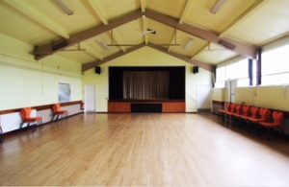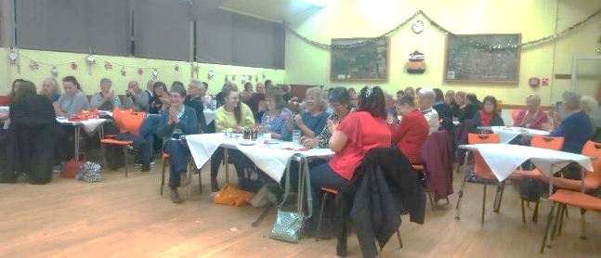

**Upcoming Plans for QVH 2020**

* **Decoration of Toilets**
* **Disabled Access for the Back Rooms**
* **New Flooring for Back Rooms**

***Our Committee Members***

**Mr Colin Miles –** Chair

**Mrs Karen Hughes –** Vice Chair

**Miss Victoria Price –** Secretary [qvhsecretary@yahoo.com](mailto:qvhsecretary@yahoo.com)

**Mr Mike James –** Treasurer[qvhfinance@gmail.com](mailto:qvhfinance@gmail.com)

**Mrs Mary Pocock –** Booking Clerk(01452) 723033

**Mrs Patricia Watts –** Valued Committee Member

**ABOUT US**

In March 2018 following the AGM we had several new faces join the Quedgeley Village Hall committee and in March 2019 following the AGM a couple of changes to those in charge of certain areas. As a committee since March 2018 we have achieved many things, we would like to give you a little insight in to some of the things we have been up to during this time. As a committee we are very proud to have such a beautiful Village Hall in our area with such wonderful facilities and as a committee we want to be able to continue maintaining our hall and work with our community to make it the best that it can possibly be provide to our users.

**WHAT ELSE HAS QVH COMMITTEE ACHIEVED?**

Over the last couple of years as a committee we have;

* Updated our website.
* Made a greater connection to our community through social media.
* Involved the community in events.
* Raised funds for the village hall.
* Decorated the two back rooms.
* Installed new Water Heaters.
* Increased Village Hall bookings.
* Accumulated contacts for Grants and Funding.

**FUND RAISING EVENTS** for Quedgeley Village Hall

**September 2018 – Summer Fete**

In September 2018 we ran a summer fete, with craft stalls, Pocket Money Stalls, BBQ, refreshments, balloon seller, raffle, tombola, hook a duck and more. With great success this led to our next event.

**April 2019 – Easter Fete with Egg Hunt**

In April we decided to do another fete. This time we had a local dance group perform and our drama group that uses the village hall on a Friday evening. Alongside this we arranged a mini egg hunt for the children to participate in which also went down a treat. Again, following great success we arranged something slightly different for Christmas.

**December 2019 – Quiz Night**

On 7th December we ran a quiz evening presented by Mike our fantastic Quiz Master. We had a wonderful raffle, and all munched on nibbles provided at the tables and at half time hot drinks, mince pies and stolen. QVH committee received some lovely feedback including how wonderful it was to see fresh faces and that they had had a cracking time and when would the next quiz be held.

**As a committee we are all very proud of what we have achieved for the Village Hall in the past 1 – 2 years. We do have more events upcoming please see Upcoming Events.**

**UPCOMING EVENTS**

**AGM – Tuesday 17th March 2020**

On Tuesday 17th March 2020 Quedgeley Village Hall will hold our Annual General Meeting at **7pm** in the Back Room (Entrance through the carpark). All are welcome and new members to the committee are also greatly received. We also welcome a member of each Village Hall user group to represent their group. If you feel you would like to join us for our AGM, we look forward to seeing you!

**EASTER FETE – Sunday 29th March 2020**

QVH will be hosting another Easter Event on this date between 12pm and 2pm; with performances on stage and Easter Egg Hunt, Craft and Food Stalls, Refreshments and more. Fun for all the family. 50p entry. All funds go to the upkeep of the Village Hall.

**Quedgeley Village Hall Committee**